
government high school
Sindhi Jamaat Co-Operative Housing Society (SEMIS 408170153)
Bin Qasim Town District Malir Karachi
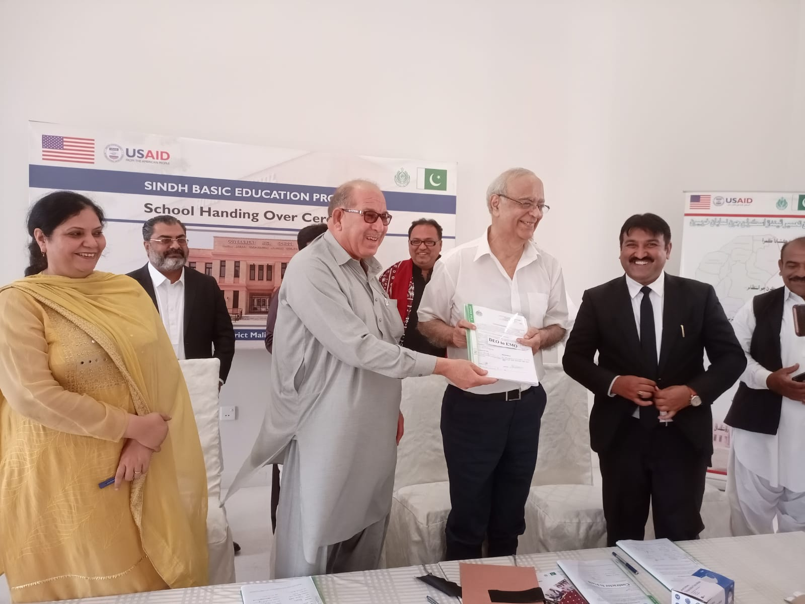

SMB STAFF BIO DATA
GHS Sindhi Jamaat Co-Operative Housing Society, Bin Qasim Town Karachi
Year 2022-2023 - Semis Code# 408170153
S No | Name | Designation | Location | Program | CNIC No | Date of Appointment
1 | Syeda Samiya Kazmi | Principle | SJCHS | EMO | 41304-8178382-2 | 06-Oct-2021
2 | Miss Shumaila | Directress | SJCHS | EMO | 42501-6902056-2 | 01-Jul-2022
3 | Miss Saika | Teacher | SJCHS | EMO | 42501-7160658-6 | 01-Aug-2022
4 | Miss Tooba | Teacher | SJCHS | EMO | 42501-8210999-2 | 01-Aug-2022
5 | Miss Saba | Teacher | SJCHS | EMO | 43203-9105637-2 | 01-Aug-2022
6 | Miss Shehzana | Teacher | SJCHS | EMO | 42301-0658911-0 | 01-Aug-2022

